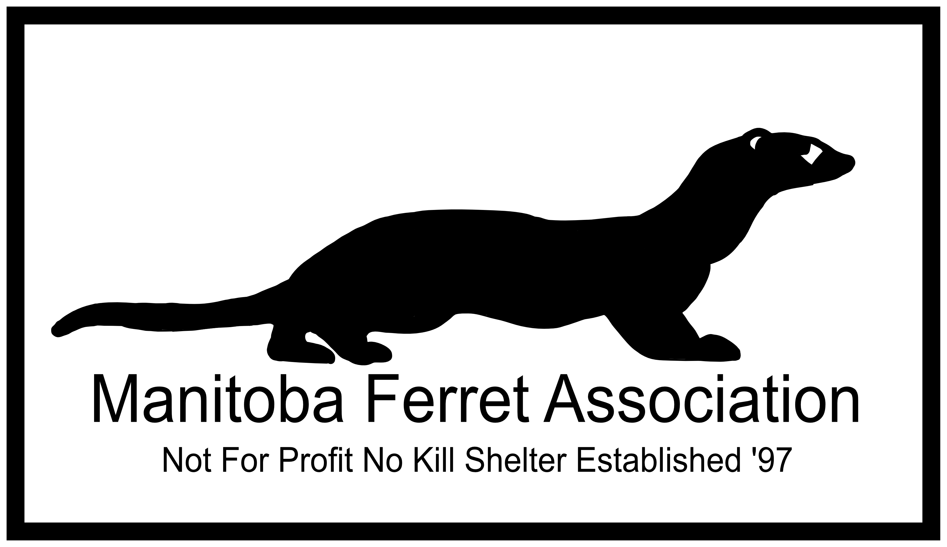

TO PROVIDE THE BEST POSSIBLE CARE TO ALL FERRETS
SPONSORSHIP CONTRACT

Name: Date:

Address:

City: Province: Postal Code:

Phone: Cell:

Work: Email:

I/We agree to foster for a period of;

ONE YEAR

LIFETIME

OTHER:

Please initial after each;
I/We understand that monthly sponsorship fee will be applied towards the general care and medical costs for the above ferret(s).

I/We understand that I/We will receive a biography and photo of ferret(s).

I/We understand that I/We will be advised if a sponsored ferret passes away.

I/We understand that I/We may visit the ferret by appointment at the shelter.

Sponsor Signature: Date:

Shelter Operator Signature: Date:

