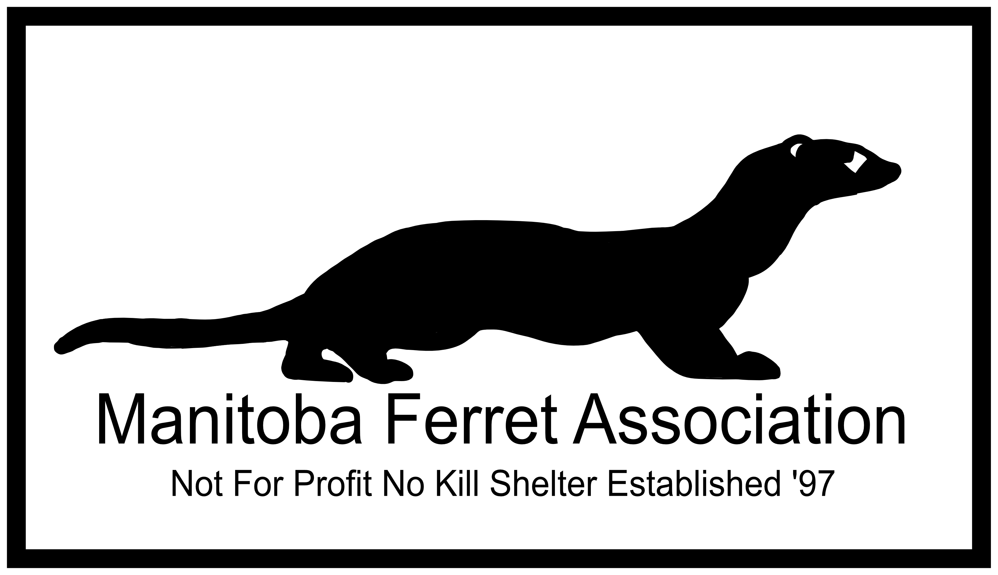

TO PROVIDE THE BEST POSSIBLE CARE TO ALL FERRETS
FERRET SITTING / BOARDING AGREEMENT

Members of the Manitoba Ferret Association provide ferret-sitting and boarding services. This agreement is intended to ensure the health and safety of the ferret(s) and to detail the responsibilities of the owner and the volunteer.
Fees for boarding will vary depending on the number of ferrets, and must be settled upon by the owner and the Manitoba Ferret Association before this agreement is completed. In cases of long-term boarding for periods of thirty (30) days or more, any arrangement to pay by instalments must be approved by the MFA executive. Any ferret(s) left unclaimed by the owner at the end of the boarding period without renewal of the agreement for further boarding services (and partial payment if applicable) becomes the property of the Manitoba Ferret Association.
I, (print) , (sign) , affirm that I am the owner of the ferrets listed. I have ensured that the ferrets are free of ear mites, fleas, ticks, and any communicable diseases. I affirm that the ferrets’ vaccinations for distemper are up to date. I agree that I am responsible for any and all expenses resulting from ear mites, fleas, ticks, or any communicable diseases brought into the volunteer’s home by my ferrets. I agree to pay all expenses necessary to ensure the health and safety of my ferrets including food, litter, medications and vet bills up to a maximum of $ (or “no max”). If the cost of emergency medical treatment exceeds this maximum amount, I authorize the volunteer to surrender the ferret to the Manitoba Ferret Association. Depending on the ferret’s age and the treatment required, the Manitoba Ferret Association may choose to euthanize the ferret.
I will provide the volunteer with the ferret(s) favorite toys and/or treats. I agree that during the boarding period, the volunteer has the authority to make all decisions concerning the welfare of my ferret(s) in the event I cannot be contacted. I agree that the MFA and its volunteer are not liable for any accident or illness that affects the ferret(s) during the boarding period.
I, (print) , (sign) , agree to board the listed ferret(s). I will keep them in clean and spacious quarters while they are in my care. I will ensure that they have access to their preferred food and clean water at all times, and will play with them daily. I will not remove the ferret(s) from the premises without the consent of the owner. If a medical problem arises I will make every effort to contact the owner. If I cannot contact the owner I will take the ferret(s) to a vet of my choice at the owner’s expense, up to the specified maximum amount. I will return any toys and/or treats provided by the owner that the ferret(s) have not consumed, destroyed, or hidden very well.
If one or more of your ferrets is a biter, what usually causes it/them to bite?
Are your ferrets used to other animals? Which types?
Are your ferrets usually caged, or are they free range?
How much daily play time do your ferrets usually get?
Is there anything else we should know about them?
Please fill out the next page for ferrets being watched – if you have more than two just print off multiple copies and adjust numbers as needed.
Ferret 1:
Name: Age: Sex:
Colour/Pattern:
Preferred Food: Preferred Treat(s):
Water container: Litter box usage:
Temperment: If other, specify:
Date of Rabies Vaccination:
Date of Distember Vaccination:
Health issues: Medications:

Ferret 2:
Name: Age: Sex:
Colour/Pattern:
Preferred Food: Preferred Treat(s):
Water container: Litter box usage:
Temperment: If other, specify:
Date of Rabies Vaccination:
Date of Distember Vaccination:
Health issues: Medications:

Owner information:
Name: Date:

Address:

City: Province: Postal Code:

Emergency Contact:

Name: Email:

Phone: Cell:

Alternative Emergency Contact:
Name: Email:

Phone: Cell:

Supplies Furnished to volunteer:
Bowls: Water Bottles:
Food: Treats/Ferretone:
Litter boxes: Litter:
Hammocks: Sleep Sacks:
Cages: Toys:
Other:

